Pitch Shifter Hardware Control

# /Users/jake/Dropbox/projects/audio_fx/Deliverables/Diagram.png

# Pitch Shift Control

* **KEY0:** Pitch reset (p = 1, semitone = 0, no shift)
* **SW0 OFF:** pitch factor (inharmonic multiplier)
  + KEY1: Pitch shift decrement 0.1
  + KEY2: Pitch shift increment 0.1
* **SW0 ON:** semitone mode (half step mapping)
  + KEY1: Semitone decrement 1
  + KEY2: Semitone increment 1
  + 

# I/O Control

* **SW5 ON:** Enable dry input routing to right output channel
* **SW5 OFF:** Disable right output channel (Wet only)
* **SW7 ON:** Microphone input
* **SW7 OFF:** Line Input

# UART Control

*Sends data to our GUI*

* **KEY3:** Send UART buffer (current pitch factor, switch config and audio buffer)

# Effects Control

*SW1 – SW4: ON is enabled, OFF is disabled, only one can be enabled*

* **SW1 Melody Auto tune:** pitch changes according to user’s melody and tempo
  + Keys control pitch shift
* **SW2 Pitch Decay:** Input is echoed, pitch shifting each echo by a given rate
  + KEY0: decrease pitch change rate
  + KEY1: increase pitch change rate
* **SW3 Echo:** Input is echoed with constant pitch and variable decay
  + KEY0: decrease decay rate
  + KEY1: increase decay rate
* **SW4 Loop:** Loop input indefinitely
  + Keys control pitch shift

Pitch Shifter Software GUI

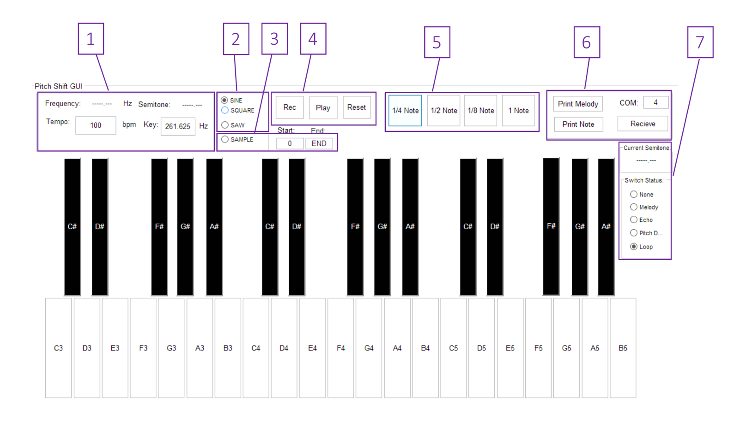

1. **Global settings:** Displays current note as well as global tempo and key
   1. User an input tempo and key note frequency
2. **Waveform select:** Choose waveform to map to piano keys
3. **Sample Mode:** Maps sample (from UART) to piano keys using pitch shift algorithm
   1. User can input sample start and end points
4. **Melody Controls:** Play, record or reset a melody
5. **Note length:** Sets duration of next note played
6. **UART Control:** Initialize and receive UART
   1. User can set COM port
   2. Receive, then press KEY3 on hardware to send switch config, current note and an audio sample
   3. Audio sample is used when in Sample Mode
7. **Hardware Status:** Indicates current pitch setting and Effects switch configuration